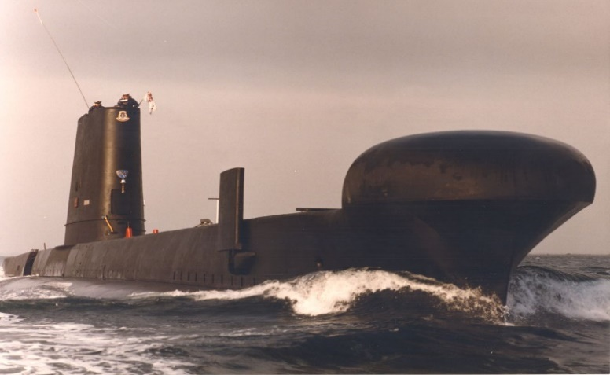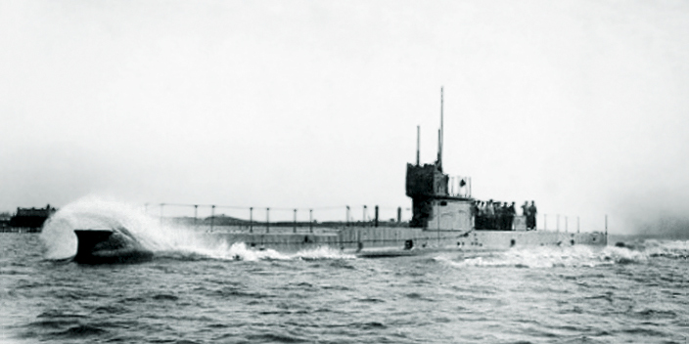

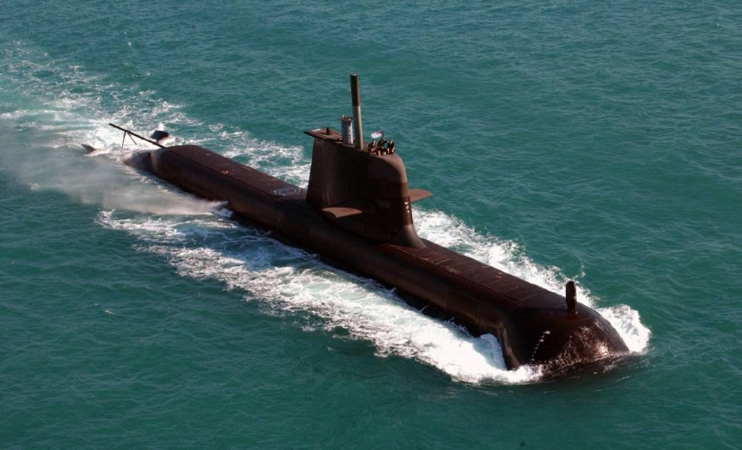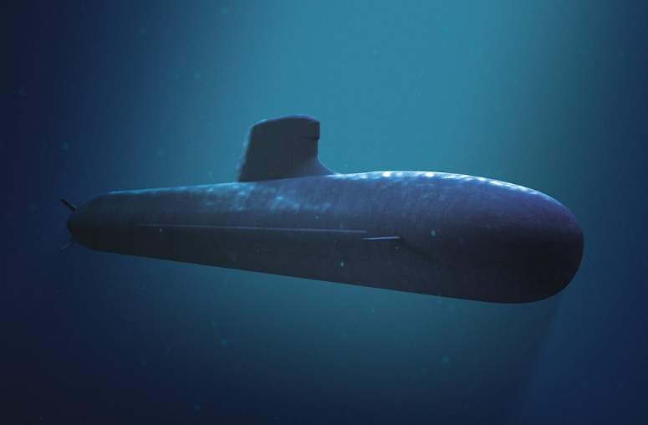Aa

More stories of the exploits of submariners are required to make a better newsletter. Please send to [secretarysaaqld@gmail.com](mailto:secretarysaaqld@gmail.com)

General Meeting/AGM

1030, 24th July 2021

Coorparoo RSL, Holdsworth St, Coorparoo.

Let us know you are coming by clicking on the next meeting page on the website and fill in the form.

Everybody welcome even visitors from Victoria as long as they are submariners

Subcon 21 – Holbrook

1st – 4th October

*It is still on. More information on our website or the National website*

Due to COVID restrictions most of the places for events are filling fast. Get in while you can

**More on Subcon**

QANTAS are opening up a Brisbane-Albury-Brisbane route and there is a ticket sale on this route commencing on 1 July.  Albury is only a 25-minute drive from Holbrook. The cost of a return ticket is very reasonable.

2. Members will be advised about SUBCON payment details in July.

**SAANQ Branch.**

*Due to lack of interest by the members, their executive has decided to fold up the tent and go home.*

*This can easily happen if you do not keep interested in the association.*

**Keep involved and interested**

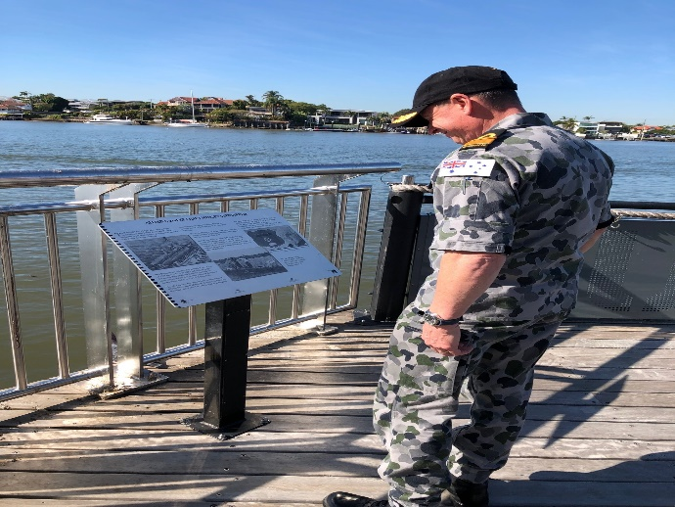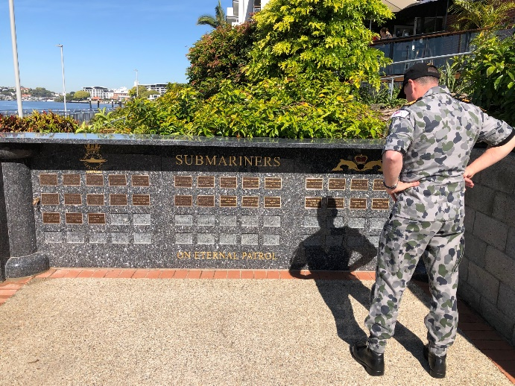

**Burnett Heads Memorial to the X Craft**

**For those submariners who do not know about this memorial in Burnett Heads. The memorial is to two divers from the X Craft who were lost and never recovered.**

**We are hoping to add a couple of plaques to the memorial to explain what this is really about.**

**More to follow.**

**17th June 2021**

Cdr Phillipa Hay, CO HMAS Morten, diverted RADM Mark Hammond to his first visit to Submariners Walk Heritage Trail, Teneriffe during his brief and busy visit to Brisbane.

RADM Hammond is the RAN’s most senior serving submariner. He was touched and impressed by the memorial as he remembered some of the names on the wall

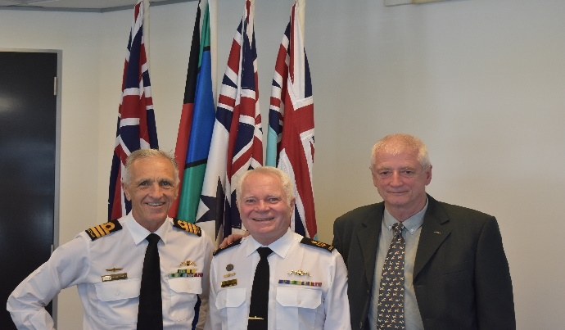

Queen’s Birthday Honours

CDR Phillipa Hay , Co HMAS Morten

Awarded a Bar to her Conspicuous Service Cross “ for outstanding achievement in the field of Maritime Planning and Operational Command.”

She made history when in 2020 she was the leader of Task Force One during Rimpac exercises. She was the first non-US Military woman to do so.

Our congratulations from SAA Qld Inc



**Grey Nomads**

I realise there is a lot of you travelling about especially Victorian types escaping lockdown or the cold.

If any members are harbouring these escapees let your fellow submariners know so they can have a catch up with the ex-submarine community.

They are more than welcome at any meetings etc in Queensland.

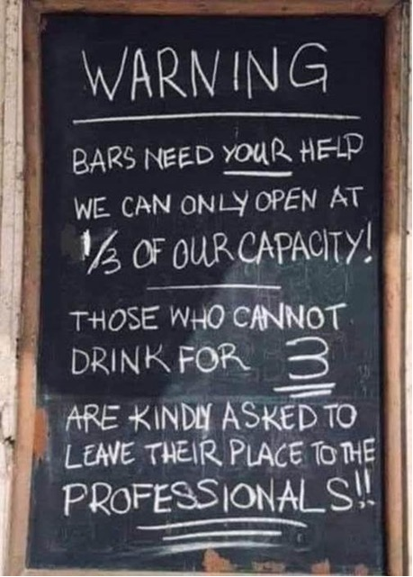

Anyone in the association who sees a problem on our website that is not accurate, or you think can be improved. Let me know so this can be rectified. Do not forget to Log In so you can see the latest news etc. Anything for the Agenda for the General Meetings and AGM to the secretary soonest.

Always available Ross Walters 0478541303 E: secreatrysaaqld@gmail.com