Submarine Assoc. Australia
Qld Branch
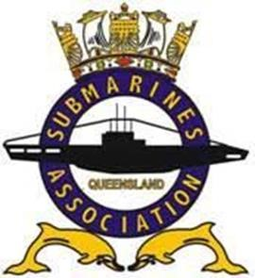
Newsletter February 2021
Dear Members,
Hope you all have had a great Christmas and New year and have remained safe and well during this period.
It has been an uneventful time for the association except for ex-ABCK Tom Liddane and Kerry “Magilla Gorilla” Thompson passing away before Christmas. Sad news to lose Gary “Bronco” McGinn. Mick Dunne has been ill over the last few months, but we are hopeful he is on the mend now. Bob Trotter has had a stroke recently but also on the mend. You cannot keep a good man down.
COVID is still with us and not going way anytime soon. That might be why I am so active on e-mail to notify everyone of what little information we have.
Anzac Day is still in the air now. We are trying to find out whether a Dawn Service at Teneriffe will be allowed but the inability to control numbers will make it untenable. The march now will be limited affair in the showgrounds. We have 4 volunteers to carry the banners around the showground all of which are our younger members from “C” boats. Great to see.
Our President, Bill Clayton informed everyone at the meeting that he will not be standing again as President due to moving to Western Australia at some point this year. That is still being negotiated but he will stay as President until the AGM in late June. We still need a Social Secretary and anyone willing to help. A volunteer is still better than 10 pressed men.
We have a lot of ex-submariners who live in our area. We also have a lot of people who have not kept us up to date of their details so we can stay in contact. If you are unsure if your details are correct, please contact me by e-mail or phone to update them. I will be trying to contact those who have drifted away over the next couple of months to try and re-establish that connection.
We trialled using Google Meet at the meeting. It worked well but we only got two people to come online. We need to refine a couple of issues but intend to keep doing this to help all stay in touch.
Submarine News

How the Submarine Was Born  The National Interest - 4 January 2021  The concept of a ship that could submerge beneath the water and then resurface dates back as far as the late 1400s, when Italian Renaissance artist and inventor Leonardo da Vinci claimed to have found a method for a ship to remain submerged for a protracted period of time. | 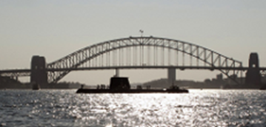  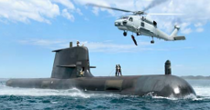  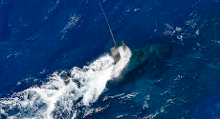
Israel’s Nuclear Submarines are Netanyahu’s Ace in the Hole
The National Interest - 3 January 2021
Here's What You Need to Remember: Having three submarines in operation generally means at least one is at sea at any particular time, a necessity for a sea-based nuclear deterrent. The Dolphin class reportedly carries up to sixteen torpedoes and missiles; if the submarines’ primary task is nuclear deterrence, half of its weapons space might be allocated for carrying nukes. The result is that at any given time Tehran is likely in the nuclear crosshairs of an Israeli submarine

Canada’s nuclear future brightens  Physics Today - 2 January 2021  Although the Canadian and US nuclear industries have shared origins in World War II, their paths soon diverged.  On a windswept field near the shores of Lake Ontario in mid-November, Canadian politicians and nuclear industry executives gathered to announce plans to build the country’s first new nuclear reactor since the early 1990s. A month earlier US Department of Energy Secretary Dan Brouillette and Romania’s Minister of Economy, Energy, and Business Environment Virgil Popescu signed an $8 billion agreement in Washington, DC, that paves the way for the construction of two new Canadian-origin reactors at a nuclear power plant on the Black Sea. Two Canadian reactors are already located there. | Collins class subs get $24m Aussie system overhaul  The Australian Navy's ageing Collins class submarine fleet will undergo a $23.7 million upgrade of its sonar systems, including the installation of an Australian designed and developed mine avoidance system.  Defence Minister Linda Reynolds will announce on Tuesday that Thales Australia has been awarded two contracts to undertake the upgrade, which will also include a new high frequency intercept array.
If you open the attachment to the right, you will find an interesting article about the new Attack Submarine contract.

