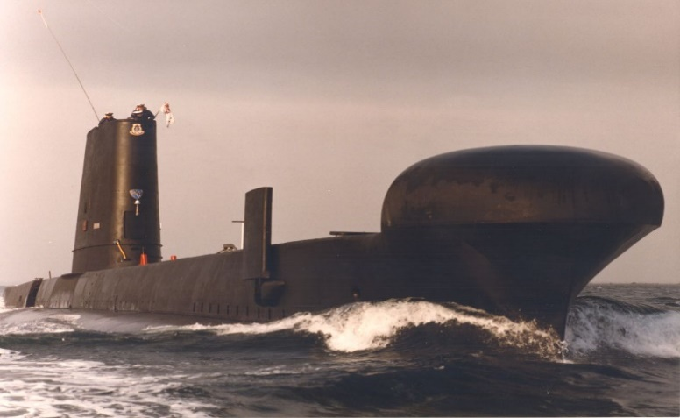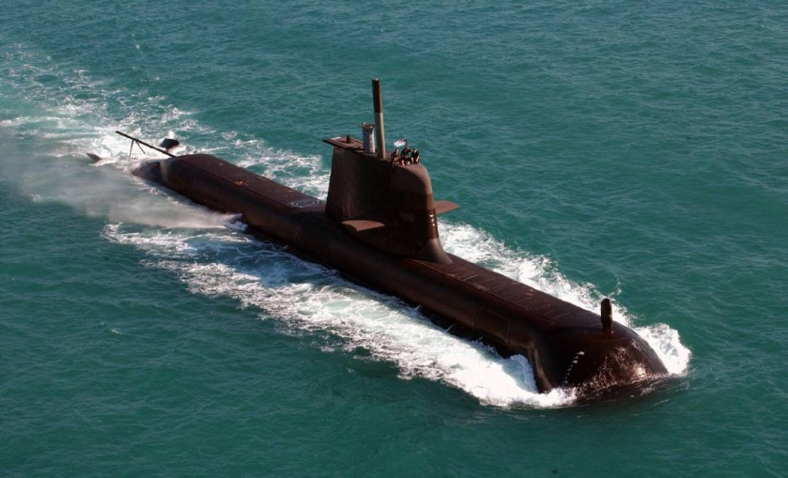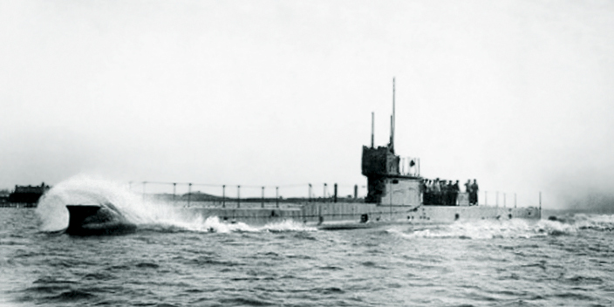De ***Newsletter September 2021.***

Dear Members,

I must apologise for not writing earlier but we in the management committee have been busy trying to finish up the work created by Office of Fair Trading under which we, as an Incorporated Association, must complete certain returns yearly. A major component of this return is the financial year statement.

As you may know our treasurer, who was only reinstated at the AGM, has had to resign due to his health. Mick is doing fine again but cannot continue with this position. As he was unable to deliver his statement at the AGM, the OFT have informed us that the report must be presented to the membership again. Terry Shorrock has volunteered to fulfil the vacated role of treasurer and will deliver a financial report for 2020- 2021 and the 1st quarter of 2021-2022 report.

Hence, on the 9th October 2021 we will hold a Special General Meeting at the Coorparoo RSL and stream live on Google Meet. We will also have a normal General Meeting after this to consider certain business and functions for the remainder of 2021 and early 2022. The agendas for both meetings will be posted with this newsletter.

Special General Meeting and General Meeting Google Meet details

Saturday, 9 October · 11:00am – 12:30pm

Google Meet joining info

Video call link: <https://meet.google.com/mst-qvnc-rzy>

**Seafarers Service** was held at St John’s Cathedral on the 5th September 2021 but due to virtually no notice only one person attended, and we didn’t have a representative.

**AE1 Memorial Service** was held on 12th September at Kallangur. Several members attended to pay our respects to our World War one submariners who perished off Rabaul in 1914. The Pine Rivers Naval Association organised this service and hosted a meal and refreshments after at “The Anchorage” Ogg Rd, Murrumba Downs. A couple of photos on the website.

Don Currell sent me a note on Korea’s new class of submarine which is really good, but I think that has now been superseded by the new of Australia to enter the nuclear age. I would assume we will be buying submarines from UK or the US.

Korea’s New Submarine.

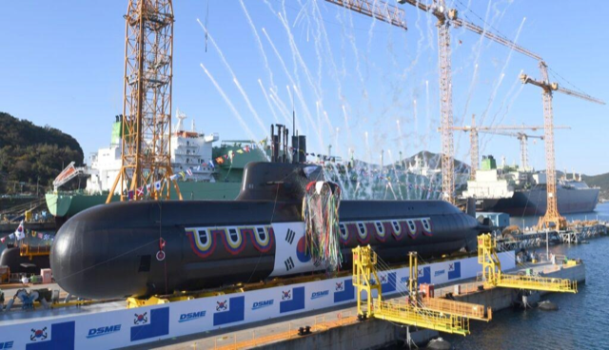

Amazing Specs! 600-800 volts, about 1800 lbs. estimated 20 days submerged ops before charging!!

For those who missed the notice, Ron Bateman ex-ERA passed away about 3 weeks ago. A reminder to keep up with our friends and comrades so they can be helped if required or just given our friendship during their health issues.

**SAA.QLD.Weebly.com** – our website. Holds a lot of information and news. With a recent update to the layout, we have addressed some security concerns about who has access and what should be public. If you cannot get access to the website contact me, the secretary, who will arrange access for you.

**SWHT Honour Roll Wall**

As many of you know, the additions to the Honour Roll wall have now been completed. These additional wings have significantly increased the space available for plaques.

Again, well done to Don and the sub-committee for making this happen.

Anything for the newsletter and website or just generally to stay in touch your committee is always available to pass on the information.

Yours, aye

Wombat

[secretarysaaqld@gmail.com](mailto:secretarysaaqld@gmail.com)

**Remember to stay COVID safe (i.e., don’t go south) and get your jabs.**