SUBMARINES ASSOCIATION AUSTRALIA

QUEENSLAND Inc.
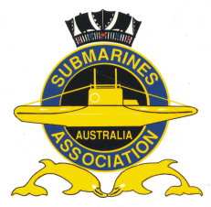

The President

Submarines Association Australia Queensland Inc.

Mr Andrew Clowes

Has much pleasure in inviting

Members of the SAA Qld Inc and Guests

For Remembrance Day Service

At Submariners’ Walk Heritage Trail, Cnr of Beeston Street and Macquarie Street, Teneriffe

11th November 2022, commencing at 11:00 AM

RSVP by 4th November 2022

Dress: Military Uniform/ Business attire with Medals

Don Currell email duckrun01@gmail.com or 0437025462

