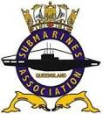 May 2020 Update and Bits and Pieces

The following information etc. will bring you up to date till we can hold our AGM & GM once the restrictions allow. In preparation for the AGM please find a Nomination Form at the following Link https://saaqld.weebly.com/ you will need to login to the members only section to gain access to the Form or Copy the Form at the bottom of this email, complete and send to the following email address mailto:secretarysaaqld@gmail.com or post to The Secretary, 2 the Nook, Underwood, Q 4119.
- From the President
Dear Members,
I trust you are all enjoying what little we are able to do during these trying times.
Many of us are in that danger bracket where we have to be extra careful. As far as I am aware I haven’t been informed of any of our members being affected by COVID 19 personally.
Following the news as it changes so often it’s starting to shed some light at the end of the tunnel.
Once we get the OK from our State leaders we the Committee will set a date for our next meeting which may even be our AGM.
Please follow the guide lines and stay safe and I hope we can all catchup soon.
Regards Bill.

- The SWHT HRW Sub Committee have sent out 3 application kits. And advise a couple of plaques have been completed by Heritage Masonry for installation.
Note: The SWHT/HONOUR ROLL WALL page and the drop down page HRW EXPRESSION OF INTEREST have been updated on our website, to better meet the requirements for applications set by the Sub -committee.

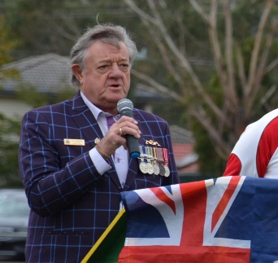
Vale : Don ‘Tich’ Parsons.
Half-mast flags to farewell Lilydale RSL President

Council will fly its flags in Lilydale at half-mast on Friday, 22 May, to commemorate the life of the late Lilydale RSL president, Don Parsons.
Yarra Ranges Mayor, Richard Higgins said that Don had passed away unexpectedly earlier in the month and that his life would be commemorated on Friday afternoon.
Don was a well-loved member of the community in Yarra Ranges and had achieved much for his club and the community since becoming Lilydale RSL president in 2014,Cr Higgins said.

One of these achievements was the stellar work of the RSLs in the area to commemorate the Centenary of World War One, but I am saddened to say that three projects he worked hard on,the Seville War Memorial, the history of the Lilydale RSL and the recreation of the Digger statue on the Lilydale War Memorial will be completed in his absence.
Don served in the Royal Australian Navy for 34 years, spending nearly 18 of those years at sea, as a submariner on the HMS Sealion, HMAS Oxley, HMAS Ovens, HMAS Onslow and HMAS Otama.
He transported Australian troops to Borneo on the HMAS Sydney, worked with Signal Intelligence in the UK and, after retiring from the Navy, ran a naval themed cafe, served as a Justice of the Peace and a Bail Justice.
Lilydale lost one of its legends when it lost Don, and many lost a close and true friend.
We will be lowering our flags on Friday out of respect for Don, his legacy and his impact on the community.

The following link will take you to a recording of the Memorial Service.

https://www.belindajanevideo.com/client-video/donald-parsons/

- For your information, an extract from.
IN DEPTH
Official Newsletter of the Submariners Association
Patron: Admiral of the Fleet Lord Boyce KG GCB OBE DL

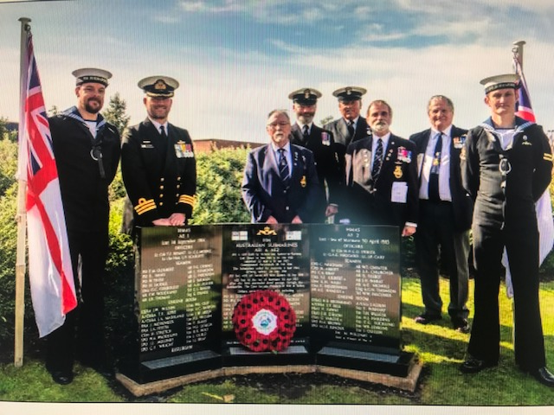

BARROW SUBMARINERS HOST THE REDEDICATION OF THE MEMORIAL TO HM AUSTRALIAN SUBMARINES AE1 & AE2
On Saturday 14th September 2019 the Barrow in Furness Branch, Submariners Association and Barrow Borough Council hosted a Rededication Ceremony on behalf of the ‘Australian E Class Submarine Foundation’ (AESMF) at the HMAS AE1 and AE2 Memorial in Ramsden Square in Barrow in Furness. The Rededication Ceremony was to mark the updating of the Memorial with two new Plaques to reflect that the final resting places of both Submarines have now been positively identified. HMAS AE2, which was lost in the Sea of Marmora in April 1915 - without casualties, was located back in 1998 but the resting place of HMAS AE1 – the first Submarine lost in WWI - in mysterious circumstances and with all hands on 14th September 1914 remained missing until December 2017 when a search, sponsored by the Submarine Institute of Australia (SIA), found the wreck at some 300 metres depth in the Bismarck Sea off Papua New Guinea. Following the discovery, the SIA then set up the AESMF with a view to determining the cause of the AE1 loss, to ensure the preservation and protection of the wrecks of both AE1 and AE2 and the updating of the Memorials to Submarine AE1 and her Crew in Sydney, New South Wales, Barrow in Furness, the Royal Navy Submarine Museum and Papua New Guinea. Back in May 2013 the Barrow Branch had been instrumental in Establishing and Dedicating the Ramsden Square Memorial on behalf of AE1 Incorporated and the AE Submarine Descendant Families – marking both the 100th Anniversary of Australian Submarines and the 50th Anniversary of the Barrow Submariners Association. The Memorial was unveiled by the Submariners Association Patron – Admiral of the Fleet the Lord Boyce and Lord Abinger – a descendant of the 3rd Hand of AE1. It was decided that the best way to update the Barrow Memorial was to install two new Plaques (funded by the Submarines Institute of Australia – SIA) identifying the locations of both submarines and the date of discovery with wording agreed by AESMF and Barrow Submariners as follows: The final resting place of HMAS AE1 and her Crew was found on 18th December 2017 and the Submarine identified on 20th December 2017 HMAS AE1 was located at a depth of over 300 metres off the Duke of York Islands in the Bismarck Sea The final resting place of HMAS AE2 was found on 11th June 1998 HMAS AE2 lies at a depth of 73 metres and 6.4 kilometres North West of Kara Burun Point on the Turkish coast of the Sea of Marmara The date of 14th September 2019 was chosen for the Rededication Ceremony as it was the exact 105th Anniversary of the loss of HMAS AE1. Councillor Kevin Hamilton – the Mayor of Barrow in Furness welcomed the Guests, including Commander David Crane, RAN (representing the Australian High Commission), Mr Tom Tribe and Mrs Marcia Bastin (representing the AE1 & AE2 Descendant Families), Mr John Woodcock (MP for Barrow and Furness), Mr Ian Vickers and Petty Officer Mark Butchart (representing the Submariners Association National Committee), Mr Ian Lofthouse (representing BAE Systems, Submarine Solutions). The Captain of HMS ANSON was represented by his Coxswain The Rededication Service was led by the Rev. Andy Batchelor (Honorary Chaplain to the Barrow Submariners). Barrie Downer read the poem ‘Entombed But Not Forgotten’, Brian Downie read ‘The Submariners Prayer’ and the names of those Commemorated on the Memorial were read out – ‘AE1 Crew’ by Steve May, ‘AE2’ Crew by Brian Downie and the ‘Spare Crew’ by Mark Butchart. Taking part in the Ceremony were members of the Crew of HMS ANSON, Sea Cadets from TS SOVEREIGN, Members of the Barrow Branch and representatives of the Royal British Legion and other Service Associations with their Standards. The Barrow Branch were Parading their new Association Standard (Standard Bearer Alex Webb) which was Dedicated at St John’s Church on Barrow Island by the Rev. Andy Batchelor on Sunday 1st September. The Rededicated Memorial was then unveiled by two Sea Cadets and two members of the Crew of HMS ANSON. This was followed by a Minute’s Silence – with the Last Post & Reveille being Sounded by a Sea Cadet Bugler. A Lone Piper – Mr. Mike Ramsey – played the Lament ‘Flowers of the Forest’. Mr Dave Oakes then laid a Poppy Wreath at the Memorial. The singing of the Australian National Anthem and our National Anthem was led by the Barrow Male Voice Choir. The afternoon’s proceedings were then closed with a speech from Mr Richard Cambridge – the Barrow Branch Chairman. The Barrow Submariners wish to express their thanks to all who participated in or supported this Rededication Ceremony

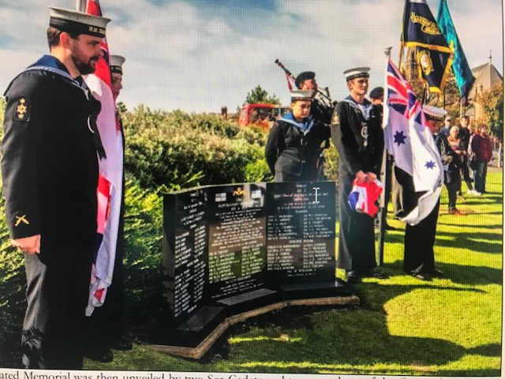

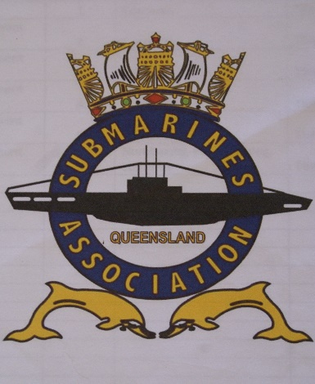
SAA Qld Inc. Branch Nomination Form
Position :…………………………………………………………
Nominee Name :………………………………………………
I accept the nomination Yes / No
Signature ………………………………………………………
Proposer Name :……………………………………………….
Signature ………………………………………………………
Seconder Name :………………………………………………..
Signature ……………………………………………………….
Date :………………..

Copy the above form, complete then scan and send to the secretarysaaqld@gmail.com
to nominate members for the following positions.
President / Vice President / Secretary / Treasurer / Welfare Officer / ESO Officer & Social Co-ordinator​
Please Note: Cut-off is at COB 14 days prior to the AGM. (date and time to TBA).

Stay Safe and Keep Well
SAA Qld Inc.

