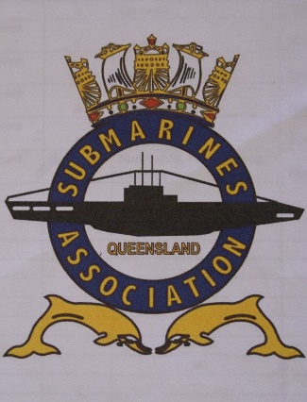 January 2020 Newsletter

Hello Members,
The following information is to assist you in marking up dates of interest on your calendars. And some tit bits you may find interesting.
NOTE : Change to the April General Meeting Date, it has been brought forward from the 12th to the 5th of April 2020. As the 12th which is the 2nd Sunday in the month just happens to be Easter Sunday.
- Anzac Day events will be the same as previous. Dawn Service at SWHT; March and Service at Coorparoo RSL; Brisbane March (Navy is tail end charlie this year); Post March - Submariners Family and Guests function at the Coorparoo RSL in the Submariners Room.
Information and Registration page for events will be active on our website shortly. Or you can contact John O’Beirne at 0422 232 314 mailto:sheepdogchef@hotmail.com or Pete Sellars 0439 442 819 mailto:treasurersaaqld@gmail.com anybody needing jeep or buggy transport for the Brisbane or Coorparoo march please let us know asap.

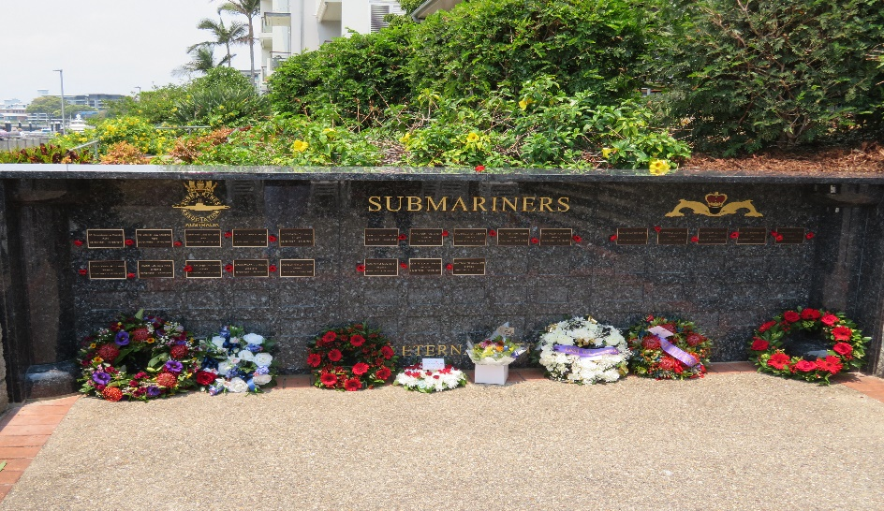
- Honour Roll Wall - Dear Members,
We would like to inform you that the Model, AKA “The Boat”, will be installed at the SWHT on Friday, 17th Jan 2020.
This is the last of the outstanding works for the SWHT and as such, a great “Full Stop”. We would like to invite all members, as well as the general public, to stop by and visit The Boat. As this is a fixed monument in the river, it is very possible that when you visit, she has “gone deep” due to the tide.
There will be an informal gathering at approximately 1430 Friday to view the model in situ.
It is also an appropriate time to confirm that the documents and procedures for the application forms regarding the Honour Roll Wall have been completed, ratified, and ready for distribution. The sub-committee will be working through the current list of interested persons over the coming weeks. If you have requested information, we ask for your patience as they work through the lists they have. If you have not received anything within 4 weeks, please email to the following link : swhthonourwall@gmail.com Lastly, we would like to take this opportunity to thank Mr. Don Currell for all his efforts and time in making the SWHT what it is today, and what it will mean to ALL submariners in the future.
Gavin Clarke Vice President SAA Qld Inc . & member SWHT Honour Roll Wall Sub-committee
- Closure of the SETT at Gosport UK
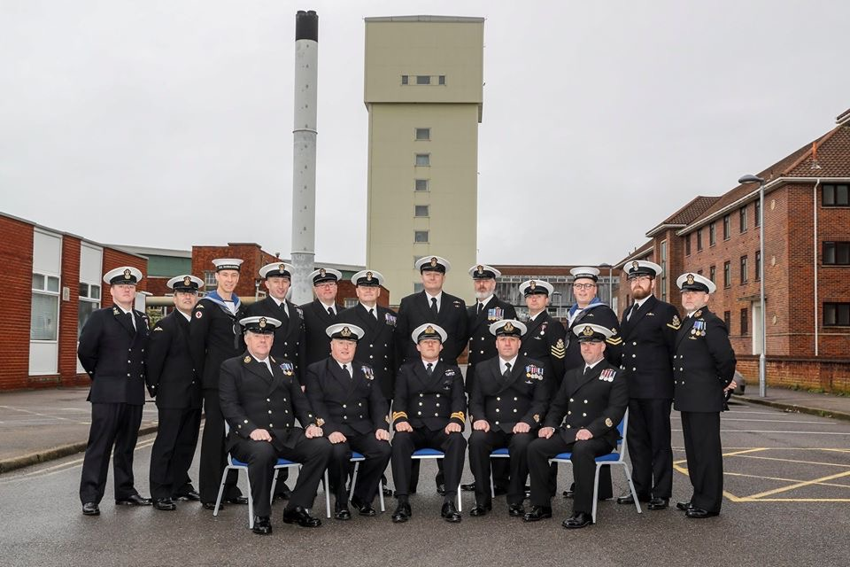
The plug has been pulled on an iconic water tank in Gosport where generations of Royal Navy submariners have been trained to save their own lives in the event of a sinking.
For the last time the team who teach sailors how to escape from a stricken boat gathered at the Submarine Escape Training Tank (SETT) before the towering structure closes.
Tens of thousands of submariners have ascended the 100ft column of warm water since 13 July 1954, when the first man entered the airlock at the bottom of the tank to simulate emerging from a sunken submarine.
With the Royal Navy’s entire submarine flotilla moving to Faslane, as well as advances in submarine design, escape training and changes in the way rescues are handled, the SETT is no longer required.
The familiar tower was built between 1949 and 1953 as part of a revamp of submarine escape training, prompted by a report drawn up by Captain Phillip Ruck-Keene just after World War 2.
The loss of HMS Thetis just before the war, and of HMS Truculent, which sank in the Thames after colliding with a tanker in January 1950 – both with heavy loss of life - as well as many other submarine accidents and experiences played a significant role in the lessons taught.
Using the circular tank, submariners were expected to escape without complete breathing apparatus – instead they used the so-called Davis apparatus, a relatively simple device that allowed them to breathe as required during the ascent, and acted as a buoyancy device as well.
During the 1960s and 1970s, around 4,500 submariners every year made the short but daunting journey to the top of the tank – it is thought it has been used more than 150,000 times in its 66-year life.
Today the tank is just one element of the UK’s submarine rescue capability, which also includes the Submarine Parachute Assistance Group (SPAG – the folk who jump from aircraft straight into the sea to help crew who’ve escaped from a boat as taught in the SETT), and NATO’s Submarine Rescue System ‘Nemo’, also based in Faslane.
The Royal Navy stopped pressurised ascent training in the 900,000-litre tank in 2012, but was still using the facility for non-pressurised drills and teaching.
During the time the SETT was in use only one British submarine – HMS Artemis – has been lost; ironically, she sank at her moorings at HMS Dolphin in the summer of 1971 while being refuelled, almost within the shadow of the tower.
Fortunately there were no casualties in the accident, which saw the boat sink in 30ft of water.
The SETT will be replaced this year by the SubMarine Escape Rescue Abandonment and Survival Training Facility (SMERAS TF). The team will be moving en-masse from Gosport to Faslane, leaving a skeleton team behind on the South Coast.
“2020 marks the end of an era, so it’s a poignant moment for all of us,” said Lt Cdr Gareth ‘Griff’ Griffiths, who is in charge of the team.
“We’re looking forward to carrying the lessons of our past many years into the future of submarine escape, rescue, abandonment and survival training.
“Our success is due, in no small part, to our commitment to one another and the unique perspective of being submariners.”
At the heart of the replacement complex at Faslane is a huge ‘abandonment and sea survival training environmental pool’, where various weather conditions and sea states can be replicated in the safety of an indoor pool.
The SETT will remain a feature of the harbour skyline – as a listed building it is protected by law for its national and international role in submarine safety, and must be preserved.
Our images from the Royal Navy (© UK Ministry of Defence CROWN COPYRIGHT, 2019) show a final training session in the SETT, the SETT team in front of the iconic tower

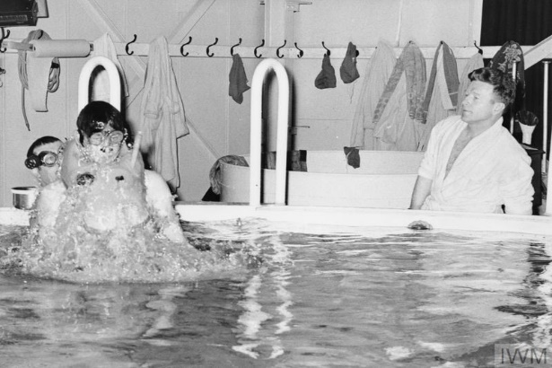

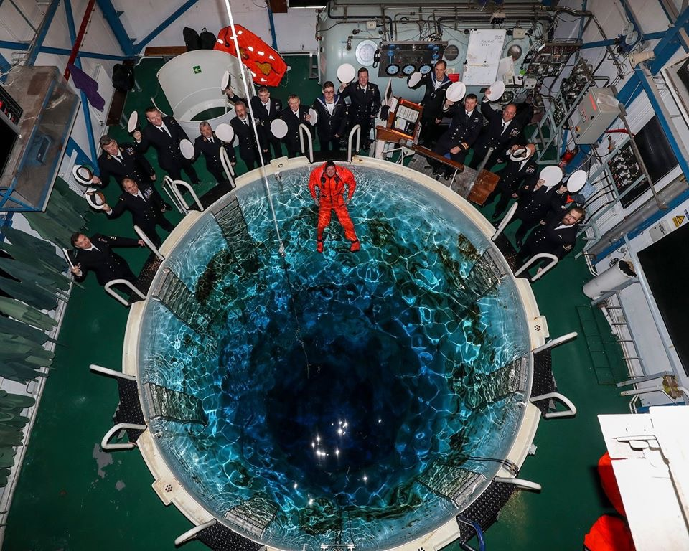

- Sick Call There are one or two of our members and their family dealing with health issues, our thoughts are with you and we wish you all the best. No names are listed, however if you know of anyone please pass on the President and Members wishes. And if any assistance or information is needed let us know and we will inform our Welfare Officer to follow up.

- Clarification of NAA Affiliation and White Ensign Magazine
Our Affiliate Fee is paid by the National Treasurer.
White Ensign Magazine, due to conflicting information coming from NAA I will contact Russell Pettis for clarification. For now, yes hard copies are available for NAA members but there is a cost involved for postage etc. The cost of the magazine is factored into the NAA membership fee, so if you are not a financial member you are not entitled.
- SUBCON 2020.

Please be advised that final costings for SUBCON 2020 are not too far away. Today I traveled to Holbrook on other Subcon business and had a chat with some of the guys in terms of costings.

Costings are now in place for most events and we only await to hear from the Holbrook Football Club who will provide our beverage service for Saturday’s dinner.

The issue is that most of the Holbrook Football Club are also fire fighters and are under some considerable pressure to keep fires under control as they have quite a few to contend with and this is their No 1 priority.

We are hoping that as soon as things calm down a little, they will hold their next meeting, however, this is a date I do not have as yet.

This is what is holding things up at the moment, but everything else is going along well.
Please accept the apologies from Dave Strangward and our committee for any inconvenience this may cause.

I am happy to field questions from any member who might want additional information.

0420532046
Mick Wood.

- Clearance Sale We have a number of old stock Polo shirts and other merchandise for Sale at rock bottom prices plus Postage. A separate Sheet with sizes available and prices will be sent out in the near future of what is available.

- Donation to late Arrivals appeal was made by SAA Qld Inc. See link below for information https://www.mycause.com.au/page/216899/the-late-arrivals-club-commemorative-run

Regards Pete Sellars

