News Letter and Update on SAA Queensland Branch Activities
April 2020
Item 1.
SUBMARINES ASSOCIATION AUSTRALIA

QUEENSLAND Inc.
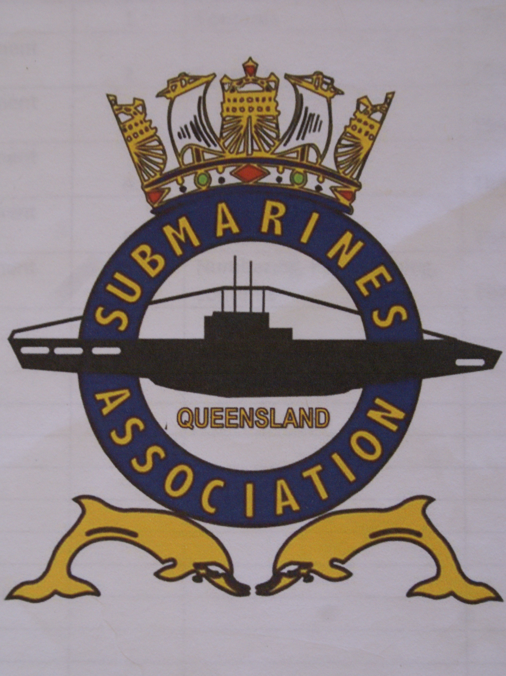

President W L Clayton
Mail: 100 Alexandra Pde
Wamuran QLD 4512
Email: presidentsaaqld@gmail.com
Phone: 0400684022

Dear Members It been some time since we have been able to meet, One as your committee and on a social level and for a general meeting. This is of course due to Covid-19 situation.
The necessary shut down by Federal, State Governments and medical authorities is for our own safety even though it has become very inconvenient for all of us.
Hopefully all our families and loved ones are safe. I have had no information to here otherwise.
It has been quite some time since we have been able to get together for meetings or socially and may be some time yet unfortunately.
I had the honour of being able to say a few words in honour of the late Terry (Coyote) Wyatt at his spreading of his ashes over the boat. Due to the Covid-19 only his wife Hellen and a small group of family members with Jan Woolrych (Celebrant) Don Currell, Barry McEweon, Gavin Clarke, Russell Clark. Coyote will be sadly missed.
From the Committee side of things Pete has been tidying up his files and has come across a mistake in that the constitution previously shown on our website had not been submitted to the Office of fair trading (OFT) for registration. This is not the fault of Pete in any way but goes back to 2013 Under Graeme Caesar, James Palmer days and hasn’t been noticed until recently. The only way to wright this oversite is to go back to the (OFT) and submit the correct version (accepted by the membership at the General Meeting, January 2015). I will communicate with Pete on the best way to do this and what repercussion could occur.

The next concern is between the Executive Committee and Sub Committee working with each other on procedures on the processes of proof of being a confirmed Submariner in particular Submariners form overseas. We both Committees need to work on our communication to get this sorted.
When time permits in the future we will work on a suitable event to put all these concerns behind us.
On the good side of things is after watching the news today we may be on the road to recovery from covid-19 situation, who knows one can only hope.
I would like to congratulate Gavin Clarke on his efforts he has put in regarding testing within the covid-19 crisis situation and anyone else from our members their families and friends, who are either in the front line or supporting roles in dealing with this unprecedented situation.
That’s all from me at present stay safe and hope to see you all soon.
Thankyou Bill
President SAAQLD Inc.
Item 2.
SAAQ Welfare report 10 APRIL 2020

I have been rather had the nose to the wheel
February trying to clear / get ahead of claims (expecting to be unavailable in March. Only to reappear 18 March 2020, heading to quarantine, where I remain.
I have an influx of people who had disappeared 3 and 4 years ago turning up to do claims OK if qualifying service applies. But is under Defence service?? Time limits apply
All lung complaints. COPD, Emphysema, bronchitis etc. you only have 20 years from discharge to have a claim accepted under VEA or MRCA (start date 1 July 2004)
For all musculoskeletal problems, osteoarthritis in arms, hands, back, hips, knees or ankles feet
You only have 25 years from discharge to have a claim accepted under VEA or MRCA (start date 1 July 2004)
UNLESS you have had ongoing treatment after discharge with a GP or specialist in the field of problem

A task out of the blue started in February which brought out the UNTRUTH that that the war widow is not automatically entitled to a War Widow Concession Card. He had a gold card so the widow is entitled to War Widow Card (WRONG)

DVA informed of death, widow gets 6 weeks of pension at the deceased current rate then nothing.
Has to apply for bereavement / funeral benefit as applicable and paid immediately (If deceases had TPI /Special rate or EDA) normally payment made on verbal notification of death.

WAR WIDOW.
Send in application with all required information and wait.
A death certificate stating “cause/causes of death”.
NEEDS to be “an accepted disability under DVA”
CHECK with DVA under Freedom of Information.
A factor from the Statement of Principle (SOP) as to which cause of death is used.
So you need to discuss with doctor who is completing death certificate. A wrong cause of death will leave the widow on the age pension.
Ian Sinclair
Welfare and Pensions Officer
SAA Qld Inc.
Item 3.
The ACT and NQLD Branches have successfully re-scheduled their planned SUBCONs (with no financial penalty) for a 12 month extension.
The following is an extract from the 2017 SUBCON Minutes:
Future SUBCONs - The following Roster for future SUBCONs were agreed by the National Executive. It was also agreed that it would be up to the host branch to choose the venue, program of events and the date.
NSW 2018 Newcastle, June long weekend, Friday 08th to Monday 11th.
TAS 2019 Venue – To be determined.. June long weekend, Friday 07th to Monday 10th.
(Post MeetingNote) Email received from Darren Thompson (President SAA TAS) Fri 29/12/2017 5:17 PM) outlining TAS SUBCON determination.
ACT 2020 Holbrook October long weekend Friday 02nd to Monday 05th October 2020.

NQLD 2021
WA 2022
VIC 2023
QLD 2024
SA 2025
NSW 2026

This will mean that the new dates (with Venue and Dates to be determined by the individual branches), will be:

ACT 2021
NQLD 2022
WA 2023
VIC 2024
QLD 2025
SA 2026
NSW 2027
TAS 2028

The SAA National Executive is requested to indicate their approval that these dates be adopted.
As the ACT and NQLD Branches need to consolidate their new dates as soon as possible with local organisations, your urgent approval or otherwise is requested.
Regards,
David Bryant.
SAA National Secretary

Note :

The SAA Qld Inc. Management Committee and SWHT HRW Sub-Committee will place as much information as possible on our website to keep you the membership abreast of what is happening during the pandemic restrictions to meetings. The following link will take you to the Home page off our website https://saaqld.weebly.com certain areas of the website are members or management committee only access. To get access to these pages you will need to have registered and use your password to log in. Have a go and page through the various drop down menus, if you have forgotten your password send us an email mailto:secretarysaaqld@gmail.com and we will reset it.
I find the Photo Album a good place to kill some time.
Kind Regards
Stay Well and Safe
Pete Sellars

